

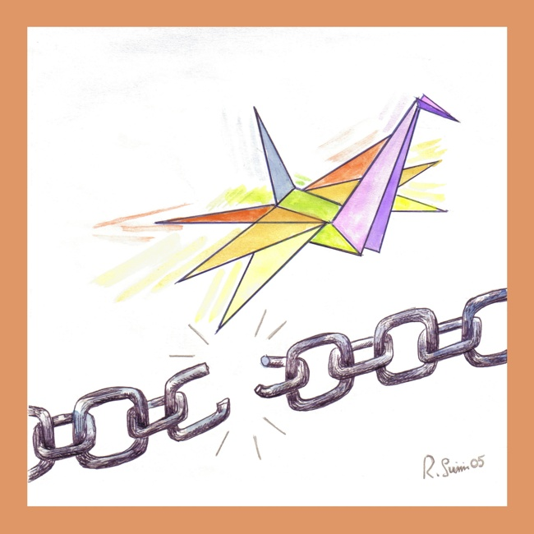

International Literary Prize

Municipality of Lugo

A TALE FOR PEACE

Third edition 2006

Contest guidelines

The contest is open to Italian and foreign authors from all countries provided they are aged 18 at the contest deadline.
Contest entrants must submit an unpublished tale or short story written in Italian and highlighting issues connected to peace as a supreme value. Manuscripts must be 5 pages at the maximum and be submitted in three typed copies. If possible, please include a further copy on diskette typed under one of the most common typing programmes. One of the copies must contain at the bottom the following: signature, name, address, telephone number, a short CV of the author and a declaration by the writer that the work is an original one. Works which were already awarded a prize in previous literary contests are not eligible.
By taking part in the contest entrants transfer the copyright of submitted manuscripts to the organising board for free. Nor are authors entitled to royalties, though writers retain ownership of them.
Entries must be sent by 25th June 2006 to:

“UNA FAVOLA PER LA PACE”
c/o Biblioteca Comunale “F. Trisi”

P.zza Trisi, n.19
48022 Lugo (RA)

Tel. +39 0545 38568 Telefax +39 0545 38534.

In order to cover a part of organisation costs entrants are kindly requested to pay an entry fee of 10 Euro payable to IPB-Italia – Postal Account no. 11114444 ABI 07601 CAB 03200 (please write on it: Premio letterario “Una Favola per la Pace”). Receipt of payment must be included in the submitted entry.
Participation in the contest is completely free for students and schools.
Submitted manuscripts will not be returned.
Submitted manuscripts will be evaluated by the following jury:
President: Daniele Serafini (writer)
Members: Susanna Agostini (representing the municipality of Florence), Emilio Bianchi (journalist), Menotti Giusti (critico letterario), Niccoletta Livraga (winner of the prize, first edition), Elena Magni (winner of the prize, second edition).
The decision of the jury will be final.
The prize will be awarded on 7st October 2006 at 16:00 at the Rossini Theatre in Lugo di Romagna, Piazza Cavour 17 during an invitation ceremony attended by important personalities.
Trophies, cups and works of art will be offered by the organising board and the sponsors of the initiative.
A special prize named “A Tale for Peace -Youth” is also established and is open to school classes and pupils of middle and high schools. Participation is completely free. Submitted works will be screened by an independent jury composed of teachers and trainers.
Further special prizes will be offered by associations and societies which share the same aims as IPB-Italia. All entrants will be awarded a participation certificate.
Prizes and certificates not received either personally nor by a delegate will be sent only to those who attach a pre-paid request to their entry.
Prize-winning and outstanding works will be published in an out-of-sale anthology kept in public and school libraries.
Participation in the contest implies a tacit acceptance of the aforementioned guidelines and of the possible publication of the writer’s identity and submitted work.

Privacy provisions: Under the Italian law on privacy, personal data will be gathered only for contest’s purposes. Submitted personal data will not be communicated to third parties for other purposes. Entrants may request that their data be changed or cancelled by writing to: “Una favola per la pace” c/o Biblioteca Comunale “F. Trisi” P.zza Trisi, n.19 48022 Lugo (RA)

Honorary President of the Prize: Dacia Maraini
President of the Prize: Fulgida Barattoni
Director: Alberto Barbero
Honorary board: Fiorella Alunni, Sindaco di Campi Bisenzio, Riccardo Nencini, Presidente del Consiglio Regionale Toscano,
Secretariat: Tamara Focardi, Sante Medri, Rita Susini.
Organising board: Pietro Amadei, Stefano Ferretti, Aniello Erra, Ferrino Fanti, Salvatore Favati, Fabiano Giusti, Menotti Giusti, Gianni Penazzi.
Under the auspices of:
Commissione nazionale U.N.E.S.C.O. – Roma, Croce Rossa Italiana – Roma, Consiglio Regionale Toscano, Provincia di Ravenna,Università degli Studi di Bologna – Facoltà di Conservazione dei Beni Culturali, Università degli Studi di Bologna – S.S.L.I.M.I.T. Scuola Traduttori-Interpreti
Friendly patnerships:
Municipality of Campi Bisenzio, Municipality of Fusignano, A.N.I.O.C., AssoKipling, The Gorbachev Foundation-Italia, Gruppo Hera

Second edition logo: “Wings for Liberty, Wings for peace” by Rita Susini

