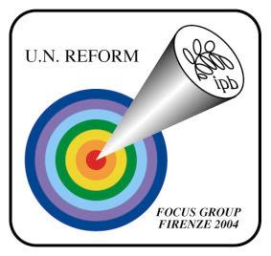

Florence 25-26 Sept. 04 Focus Group “Peace and Human Security Aspects of U.N. Reform”

DEAR PARTICIPANT

before you come to Florence to the Focus group meeting herewith we like to inform you that:

Experts and representatives of the major international organizations engaged in this issue will meet in Florence in September to analyse and interpret the results of the civil society debate on peace and human security. They will work together and explore the possibilities of new systematic approaches to the topic. These common remarks offer an important contribution to the High-Level Panel on Threats, Challenges and Change, appointed by the Un Secretary General Kofi Annan in September 2003

The question on the floor in the Focus Group is:
Which suggestions/reflections/concrete actions/new approaches can Civil Society send to the UN High Level Panel to implement Peace and Human Security in the light of the more general UN Reform aspect?

WE THANK YOU FOR THE INNOVATIVE CONTRIBUTION YOU WILL MAKE TO THE FOCUS GROUP PROCEEDINGS.

SPEAKERS: Owing to the shortage of time only one speaker per organization will be given the opportunity to speak.

For organisational problems speakers are kindly requested to hand over the abstract (5-8 lines) with the contents of their speech in advance (deadline 15/09/2004).

TIME: 8 min. max for each speaker

